Macintosh HD:Users:gwilliams:Documents:My Work:My Work:ALL FILES:Active:Maths General:PLC Crest:PLC Crest and Byline.eps

Date: 5th April 2016

**SECTION ONE: CALCULATOR FREE**

TOTAL: 35 marks

EQUIPMENT: Pens, pencils, pencil sharpener, highlighter, eraser, ruler, SCSA formula sheet.

WORKING TIME: 35 minutes

**SECTION TWO: CALCULATOR ASSUMED**

TOTAL: 19 marks

EQUIPMENT: Pens, pencils, pencil sharpener, highlighter, eraser, ruler, drawing instruments, templates, up to 3 Calculators,

1 A4 page of notes (one side only), SCSA formula sheet.

WORKING TIME: 20 minutes

Show all your working clearly. Your working should be in sufficient detail to allow your answers to be checked readily and for marks to be awarded for reasoning. Incorrect answers given without supporting reasoning cannot be allocated any marks. For any question or part question worth more than two marks, valid working or justification is required to receive full marks. If you repeat an answer to any question, ensure that you cancel the answer you do not wish to have marked.

|  |  |  |
| --- | --- | --- |
| **Question** | **Marks available** | **Marks awarded** |
| 1 | 10 |  |
| 2 | 8 |  |
| 3 | 4 |  |
| 4 | 6 |  |
| 5 | 7 |  |
| 6 | 5 |  |
| 7 | 6 |  |
| 8 | 8 |  |
| **Total** | **54** |  |

**Calculator-free [35 marks]**

This paper has **Five (5)** questions. Answer **all** questions. Write your answers in the spaces provided

**Question 1 [10 marks]**

Determine the following indefinite integrals.

1. ** [3]**



✓✓

✓ simplify integral

1. ** [3]**



✓

✓

✓

1. **  [4]**



✓

✓

✓

✓

**Question 2 [8 marks]**

Evaluate:

1.  **[3]**



✓

✓

✓

1.   **[5]**



✓

✓

✓

✓

✓

**Question 3 [4 marks]**

The curves below areand. Determine the area of the shaded region.

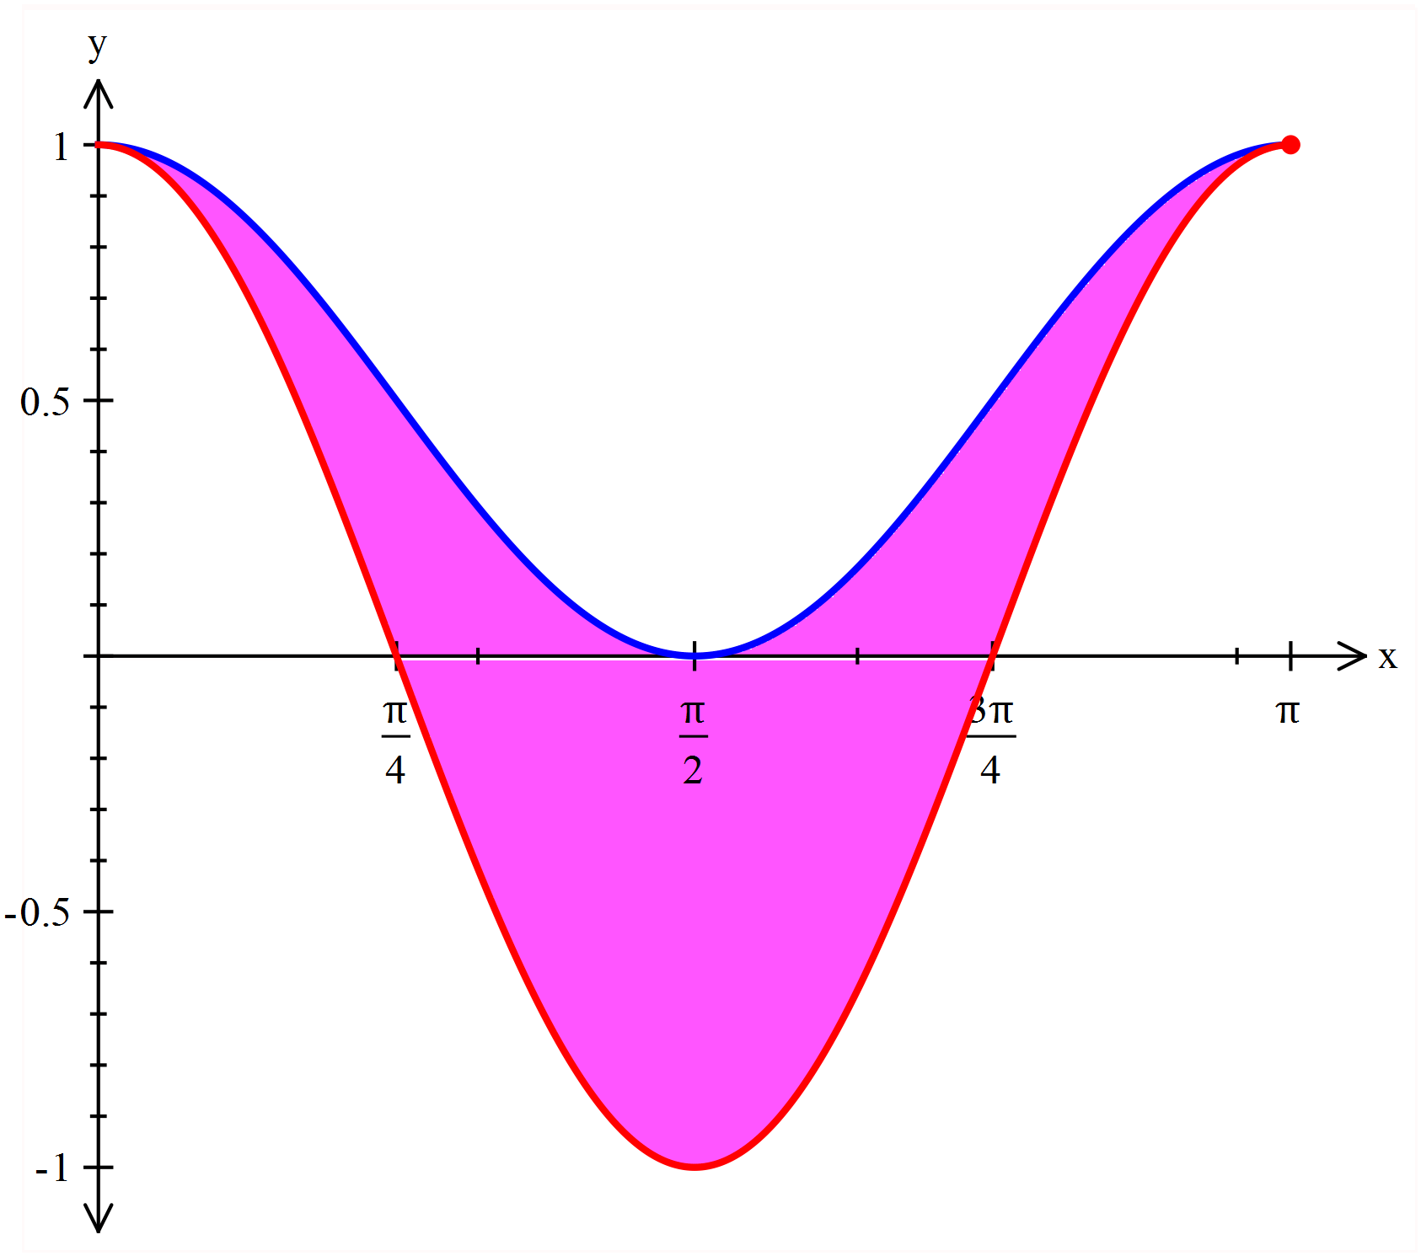

✓



✓

✓

✓

**Question 4 [6 marks]**

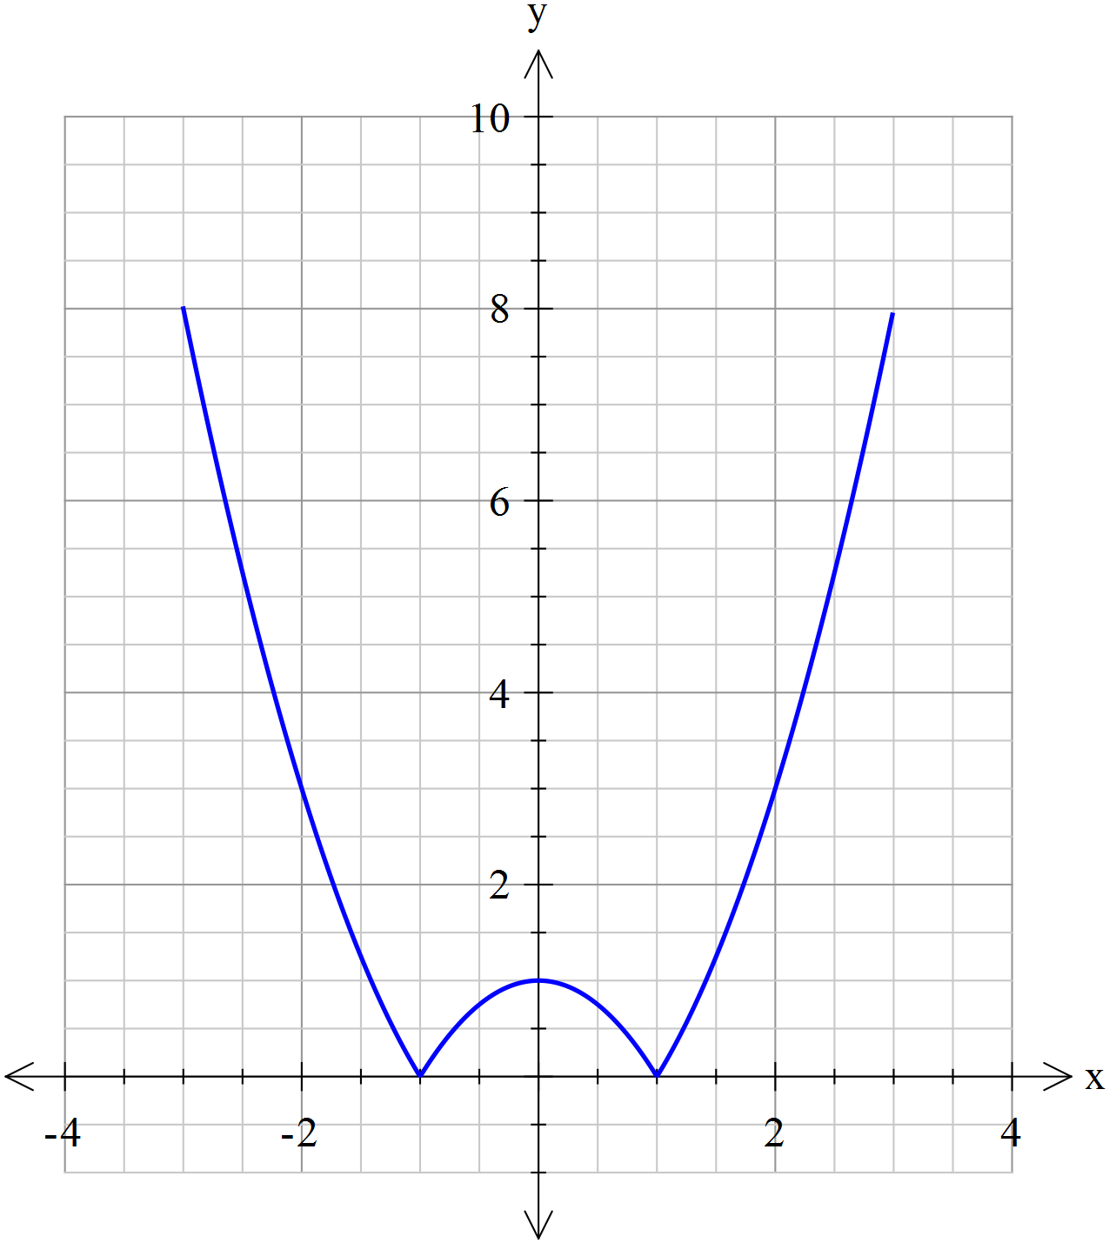

A glass is formed by rotating the function  about the y-axis as shown in the diagram.

1. Complete the middle line for the piecewise function for .



✓

**[1]**

1. Given the height of the glass is 8 cm determine the volume of the glass. **[5]**



✓

✓



✓

✓

✓

**Question 5 [7 marks]**

Find  using the substitution *x* = 2 sin *θ*.

✓



✓

✓

✓

✓

✓

✓

**NAME:……………………………………………………………………………………….**

**Calculator Allowed 20 minutes [19 marks]**

This paper has **Three (3)** questions. Answer **all** questions. Write your answers in the spaces provided

**Question 6 [5 marks]**

Determine the value of p in the system of linear equations below such that there is



1. no solution **[3]**



✓

✓

✓



1. a unique solution **[1]**

✓



1. infinitely many solutions **[1]**

✓

Not possible

**Question 7 [6 marks]**

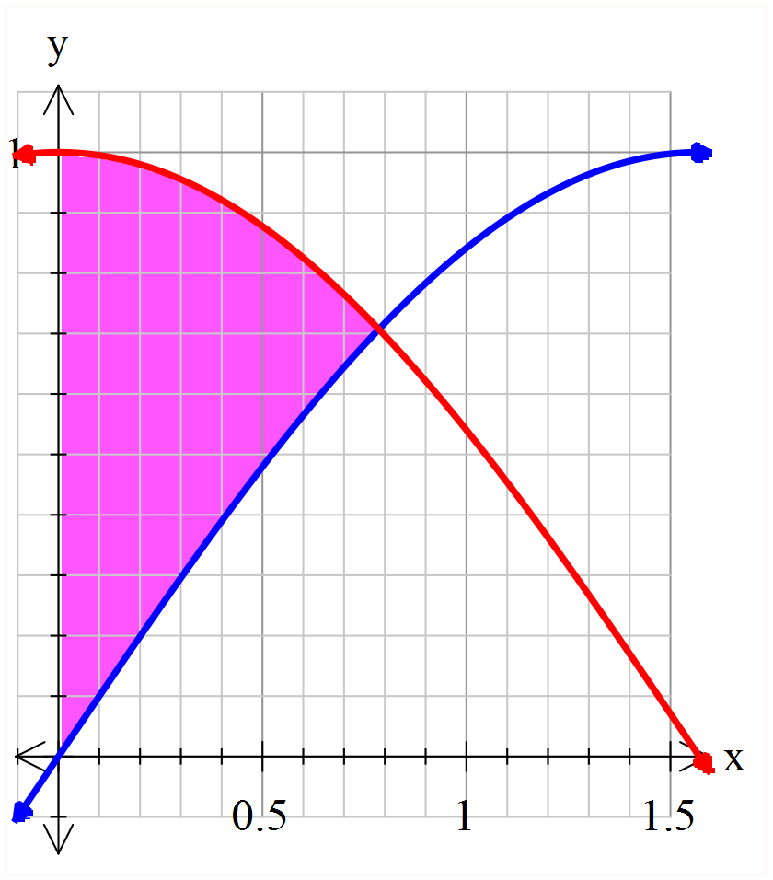

The graph at the right show the curves  and .

1. Prove that the intersection of  and , is 

for the domain .

 **[1]**

✓

Do not accept showing that 

1. Determine the exact area of the region (shaded) which is bounded by the *y*-axis and the curves

and. **[2]**



✓

✓

1. Determine the volume of revolution obtained when this area is rotated about the *x*-axis.  **[3]**



✓

✓

✓

**Question 8 [8 marks]**

1. Use the identity  to prove that  **[2]**



✓

✓

1. Find a similar expression for  **[2]**  
   

✓

✓

1. Hence show that  **[4]**



✓

✓

✓

✓